Biology Top 101
Organic Compounds
- All living things are made of organic compounds.
- Contain the element Carbon
- Carbohydrates, Proteins, Lipids, Nucleic Acids
Carbohydrates
- Monomer- monosaccharide
- Function- energy source and structure
- Tests: glucose-Benedicts, starch- Iodine
- Ex. Cellulose, glycogen, starch
Lipids
- Made of fatty acids and glycerol
- Function- energy storage and insulation
- Tests: brown paper test
- Examples: fats and steroids
Nucleic Acids
- Monomer- nucleotide
- Function- carry genetic information
- Ex. DNA and RNA
Proteins
- Monomer- amino acids
- Function- building and repairing cells, communication, transport, and regulation
- Tests- Biurets
- Examples: enzymes, hemoglobin
Enzymes
- Catalysts in living things
- Specific to a particular substrate
- Reusable
- Affected by temperature and pH

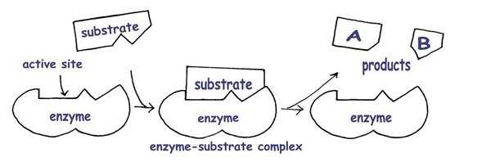
Cells
Prokaryotes
- Simple, no membrane bound organelles
- Bacteria only
- One circular chromosome
- Includes: chromosome, ribosomes, and plasma membrane
Eukaryotes
- Membrane bound organelles
- Plants and Animals
- True nucleus containing chromosomes
Nucleus
- “Control Center”
- Contains chromosomes
Mitochondria (Singular: Mitochondrion)
- “Powerhouse” of the cell
- Produces energy in the form of ATP
- Site of Aerobic respiration
Chloroplast
- Site of photosynthesis
- Plant cells ONLY
- Contains the pigment chlorophyll
Vacuole
- Storage of excess materials
- Plant cells usually contain one large vacuole
Ribosomes
- Proteins are synthesized
- Found in both prokaryotes and eukaryotes
Plasma Membrane ( aka: Cell Membrane)
- Surrounds the cell
- Regulates what enters/leaves the cell
- Helps maintain homeostasis
- Made of phospholipids with embedded proteins
Cell Wall
- Plant + Fungi cells ONLY
- Surrounds cell and provides support and protection.
*Plants cell walls Made of cellulose
Plant: Cell wall, Chloroplast, Large central vacuole
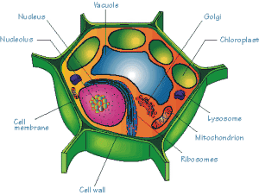
Animal
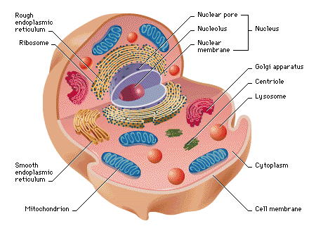
Cell Organization
Cell ->Tissue ->Organ -> Organ System -> Individual organism
- Cell Specialization: cells develop to perform different functions
- Regulated by genes
- Cell to Cell CommunicationChemical Signals (hormones) can be sent from one cell to another
- Receptor proteins on the plasma membrane receive the signal
Diffusion
- Form of passive transport (NO ENERGY NEEDED) across a membrane
- Solutes move from high concentration to low concentration
Osmosis
- Diffusion of water (also passive transport)
Active Transport
- Particles moving against the concentration gradient which REQUIRES ENERGY (ATP)
- Low concentration to high concentration
ATP
- Energy storing molecule
- Can be used for quick energy by the cell
- Energy is stored in the phosphate bonds
Photosynthesis
- Water and Carbon Dioxide used to produce Glucose and Oxygen
- H2O+CO2C6H12O6+O2
- Occurs in the chloroplast
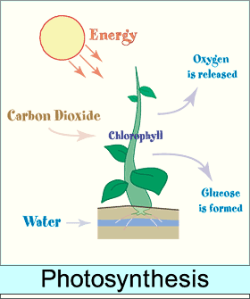
Aerobic Respiration
- Used to release energy (ATP) for cellular use
- C6H12O6+O2H2O+CO2
- Occurs in the mitochondria
Anaerobic Respiration (aka Fermentation)
- Does not require Oxygen
- also used to release energy, but not as efficient as aerobic respiration (less ATP)
- Products include CO2 and lactic acid or alcohol
- Two Types: Alcoholic Fermentation and Lactic Acid Fermentation
Autotroph
- Obtain energy from the environment
- Photosynthesis or chemosynthesis
- “Producers”
Heterotroph
- Obtain energy from other living things
- “Consumers”
DNA / RNA
- Carry genetic information
- Made of a chain of nucleotides
- Nucleotides contain a sugar, phosphate, and a nitrogen base
DNA
- Double stranded
- “Double Helix”
- Four base pairs: ATGC
- Sugar is Deoxyribose
- Found in nucleus
RNA
- Single stranded
- Four base pairs: AUCG
- Sugar is Ribose
In DNA,
*Adenine always pairs with Thymine, and
* Guanine always pairs with Cytosine
Replication
- Making of an identical strand of DNA
- “semi” conservative (one new one old)
Central Dogma
DNA mRNA protein trait
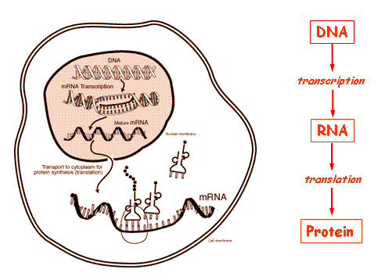

Transcription
- DNAmRNA
- Occurs in nucleus
- Complementary mRNA strand is produced from a segment of DNA
Translation
- Connects amino acids in the correct order to make a protein
- Occurs in the cytoplasm within the ribosomes
Codon: Sequence of three mRNA nucleotides that code for an amino acid
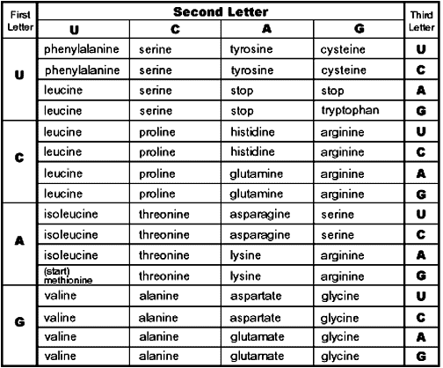
Mutations
- Change in DNA code
- May cause a change in protein produced
- NOT always harmful
Mitosis
- Cell division
- Produces two identical diploid daughter cells
- Occurs in body cells to grow and repair
- PMAT
Cancer
- Error in cell growth with causes uncontrolled cell growth
- Has environment and genetic variables
Meiosis
- Cell division
- Produces four different haploid daughter cells (gametes)
- Occurs in sex cells to form gametes
Crossing Over
- Homologous chromosomes exchange parts of their DNA
- Creates variation in gametes
Nondisjunction
- Homologous chromosomes fail to separate during meiosis
- Can lead to Down Syndrome
Asexual
- One parent
- Identical offspring
- Variation only thru mutations
- Examples: budding, fragmentation, fission
Sexual
- Two parents
- Offspring different from parents
- More variation
- Fertilization (fusion of gametes)
Inheritance
- Traits are specific characteristics inherited from parents
- Genes are the factors that determine traits
- The different forms of a gene are called alleles
- Dominant alleles are expressed, if present, and recessive are hidden
*Genotype actual alleles an individual has for a trait
Homozygous
- Both alleles are the same Ex. BB or bb
Heterozygous
- Both alleles are different Ex. Bb
Phenotype: The actual characteristic displayed by the individual (ex. brown eyes, Hemophiliac)
Incomplete Dominance
- Heterozygote shows a blending of the dominant and recessive phenotypes
Codominance
- Heterozygote expresses BOTH dominant and recessive traits
- Ex. Roan animals
Polygenic Traits
- Traits are influenced by more than one gene Ex. skin color
Multiple Alleles
- More than two alleles for a trait (an individual still only inherits two)
- Ex. Blood Type (I^{A},I^{B}, i)
type A = I^{A}I^{A} or I^{A}i
type B = I^{B}I^{B} or I^{B}i
type AB= I^{A}I^{B}
type O = ii

Sex Linked Traits
- Sex Chromosomes
  - Female = XX
  - Male = XY
- Sex linked traits are carried on the X chromosome
- Ex. Hemophilia, red-green colorblindness
Test Cross
- used to determine the phenotype of an unknown dominant individual
- uses a homozygous recessive individual as the “test”
Pedigree
- similar to a family tree
- Shows pattern of inheritance of a specific trait through a family
- Square-male, circle –female, colored in affected
Karyotype
- Picture of someone's chromosomes
- Can detect chromosomal disorders
- Ex. Down Syndrome, Klinefelter’s Syndrome, and Turners Syndrome
Human Genome Project
- Sequencing of human DNA
- Being used to develop gene therapies
Gel Electrophoresis
- Technique used to separate molecules (DNA or proteins) based on their size
- Sometimes called a DNA fingerprint
- Used to analyze and compare DNA
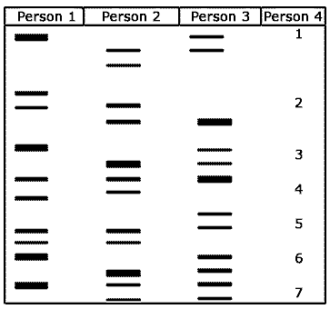
Recombinant DNA
- Cell with DNA from another source
- Bacteria used to produce human insulin
- Human gene inserted into bacterial plasmid
Transgenic Organism
- An organism with a gene from another source
- used to improve food supply, research, and healthcare

Clone -A genetically identical copy
- An organism made from one cell of another organism
Origin of Life
- Abiotic earth LACKED Oxygen
- Early organims anaerobic prokaryotes
Endosymbiotic Theory
- Eukaryotic cells evolved from prokaryotes
- Early prokaryotes engulfed other prokaryotes and developed symbiotic relationships
- Evidence includes mitochondria and chloroplast have prokaryotic type DNA
Abiogenesis
- Living from non-living or spontaneous generation
- Disproved by Redi and Pasteur’s experiments
Biogenesis: Living from Living
Natural Selection
- Theory of Evolution
- Fit organisms survive, reproduce, and pass on traits
- Requirements: Variation and Competition
Adaptations
- Trait that increases survival
- For Example,
  - Beaks that make it easier to eat insects
  - Bright flowers to attract pollinators
  - Vascular tissue in plants to adapt to life on land
Evidence for Evolution
- Fossil Record
- Biochemical Similarities
- Shared anatomical structures
Speciation
- Evolution of a new species
- must be isolation between populations
Antibiotic and Pesticide Resistance
- Populations will eventually become resistant to pesticides and antibiotics with overuse
- Short lifespans and quick reproduction allows for this
Coevolution
- Two organisms evolve in response to each other Ex. Flowering plants and their pollinators
Binomial Nomenclature
- Two word naming system
- Scientific name
- Uses Genus and Species names
- Ex. Dogs: Canis familiaris
Dichotomous Keys
- Used to identify organisms
- Paired set of questions with two choices
Levels of Organization
- Kingdom -> Phylum->class-> order-> family -> genius -> species
Phylogenic tree
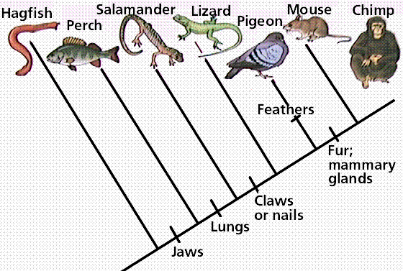
Protists
- Unicellular Eukaryotes
- Can be autotrophic or heterotrophic
- Reproduce mostly asexually
Fungi
- Multicellular eukaryotes
(yeast are the only unicellular fungi)
- Heterotrophs
- Reproduce asexually and sexually
Plants
- Multicelluar eukaryotes
- Autotrophs
- Reproduce sexually and asexually
Animals
- Multicellular eukaryotes
- Heterotrophs
- Reproduce sexually and asexually
Non Vascular Plants
- Also called Bryophytes
- No true roots or vascular tissue causing them to be small in size
- Must live in moist environments
- Reproduce with spores
Gymnosperms
- Non-flowering vascular plants
- Reproduce with cones that contain seeds
- Ex. Conifers (pine trees)
Angiosperms
- Flowering vascular plants
- Flower is main reproductive organ
- Seeds are enclosed within a fruit
- Ex. Deciduous plants
Insects
- Transport through open circulatory system
- Exchange gases through spiracles and tracheal tubes
- Most reproduce sexually with external fertilization
- Develop through metamorphosis
Annelids(segmented worms)
- Transport through closed circulatory system
- Exchange gases through moist skin
- Reproduce asexually and sexually with internal fertilization
Amphibians
- Transport through a closed circulatory system involving a three chambered heart
- Gas exchange in young with gills, adults lungs and moist skin
- Reproduce sexually with external fertilization
- Develop through metamorphosis
Mammals
- Transport though closed circulatory system involving a four chambered heart
- Gas exchange through lungs
- Reproduce sexually with internal fertilization
- Young develop in a uterus and exchange nutrients and oxygen through the placenta (placental mammals)

Viruses
- Not considered living things
- Pathogens that can mutate to resist vaccines
- Ex. HIV, Influenza, Smallpox
Genetic Disorders and the Environment
- Many diseases have both genetic and environmental factors
- Ex. Cancer, diabetes, PKU
Immune Response
B-cells
- Fight antigens in body fluids
- B-cells make antibodies
- Make memory cells after exposure to antigen
T-cells
- Fight pathogens inside living cells
- May help B-cells to make antibodies
- Make memory cells after exposure to pathogen
Passive Immunity
- Antibodies are introduced into the body
- Short term
- Such as mother transfers antibodies to infant through breast feeding
Active Immunity
- Antibodies are acquired when an immune response is activated in the body
- Long term
- Ex. Vaccines are weak/dead antigens that are introduced to the body
Parasites
- Lives on or within a host
- Benefits while causing harm to the host
- Ex. Plasmodium causes malaria (genetic influence- carriers of sickle cell are resistant to malaria)
Ecosystems
- Collection of abiotic (nonlivng) and biotic (living) factors in an area
- Together they influence growth, survival, and productivity of an organism
Symbiotic Relationships
- Relationship between two organisms in which one benefits
- Types:
  - Mutualism (+,+)
  - Parasitism (+,-)
  - Commensalism (+, o)
Predation
- Predator eats prey
- Evolve in response to one another
Carrying Capacity
- Maximum number of individuals that an ecosystem can support
- Limiting factors: Food availability, Competition, Disease, Predation, Natural Disasters

Human Impacts
- Acid Rain
- Deforestation
- Habitat Destruction
- Invasive Species
- Ozone depletion from the release of CFCs
Global Warming
- Increase in the average temperature of the earth
- Caused by the release of too much CO2 into the atmosphere which amplifies the greenhouse effect
- Burning of fossil fuels, volcanic eruptions
Bioaccumulation
- An increase in environmental toxins at higher tropic levels
- Ex. DDT and birds of prey
Innate Behavior
- Behaviors an animal is born with
- Includes suckling, migration, hibernation
- Ex. weaving of spider webs
Learned Behavior
- Behavior an animal acquires during its lifetime
- Includes: Habituation, Conditioning, Trial and error

Social Behavior
- Communication between individuals of the same species
- Can be courtship, territorial or chemical (pheromones)

