Name: Period: Date:
DNA STUDY GUIDE

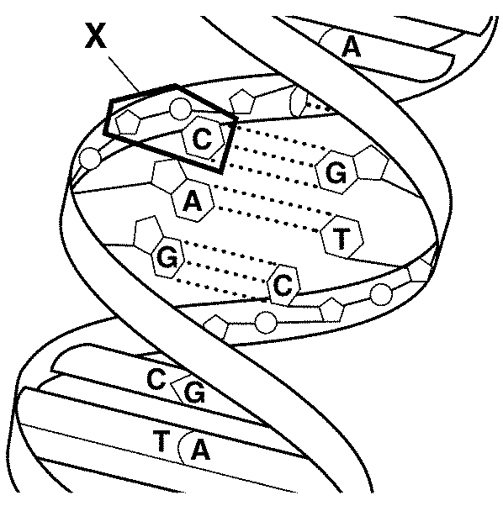
- What type of molecule is this?

- What is structure X called?

- What three things make up the answer to number 2?

- Watson and Crick described this structure as a:

- Where is DNA located in a eukaryotic cell?

- What molecules make up the backbone of a DNA molecule?

- What molecules make up the rungs of a DNA molecule?

- What are the complementary base pairs? (Which base pairs with which?)

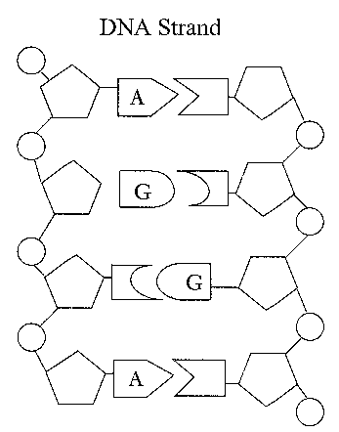
- Label the sugar molecules, the phosphate molecules, and the bases in the above diagram. Cricle and label a codon. Circle and label a nucleotide.

- In what process is DNA copied?

- During DNA replication, a DNA strand that has the bases TAGCAT produces a

strand with the bases:

- What is the same between a DNA nucleotide and an RNA nucleotide?

- What is different between a DNA nucleotide and an RNA nucleotide?

- RNA contains the sugar __________________, while DNA contains the sugar ________________

- How many types of RNA are there?

- Name and provide the function (job) of each:

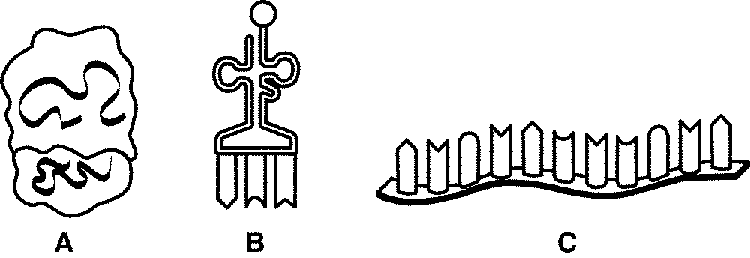

- What is produced during transcription?

- Where does this process occur?

- What is a codon?

- What does a codon code for?

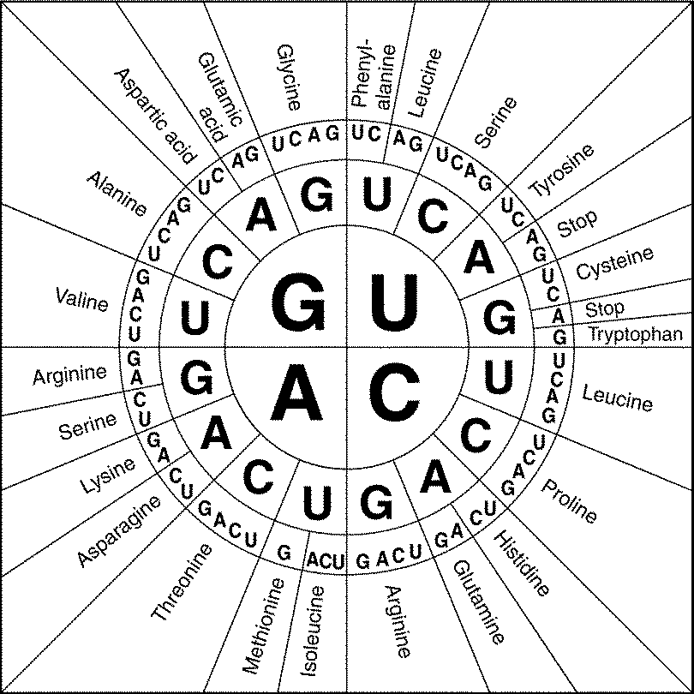
IDENTIFY THE AMINO ACID USING THE CODON CHART

GUA—

CCC—

AGC—

GAC—

UCA—

- What is produced in translation?

- What type of DNA technology has helped forensic scientists to catch criminals?
- Define the following DNA technologies
- Genetic Engineering

- Cloning

- Recombinant DNA

- What is a Mutation?

- What are some examples of mutagens?

DEFINE

- A DNA segment is changed from TAGCAT to TACCAT. –What type of gene mutation is this?

- A DNA segment is changed from TAGCAT to TACAT.-What type of gene mutation is this?

- A DNA segment is changed from TAGCAT to TAGACAT. –What type of gene mutation is this?

PRACTICE
For each of the following, transcribe the DNA to mRNA, then translate the mRNA to Amino Acids.
DNA Sequence:
- DNA: ATG AAA AAC AAG GTA CAC ATC TAG
mRNA:
amino Acids:
- DNA: ATG AAA AAC AAT TGC ACG TAG
mRNA:
amino Acids:
- DNA: ATG TAA ACC ACA CTA CAT AGT
mRNA:
amino Acids:
For each of the following sequences, fill in either the DNA, the mRNA sequence, , or the amino acid sequences that have been left blank. If several sequences might work choose any one.

- DNA T A C C G C T C C G C C G T C G A C A A T A C C A C T
mRNA _
AA _

- DNA ___
mRNA A U G A C U A G C U G G G G G U A U U A C U U U U A G
AA ___

- DNA __
mRNA U A C C A C C C C C G U A U G G C U G G G A A U A U C
AA __

- DNA
mRNA
AA MET ARG GLY PHE PHE MET VAL GLY (STOP)

