Earth and Environmental Science Final Exam Study Guide
Part I – Scientific Method and The Lithosphere
Scientific Method
- Draw examples of the following types of graphs:
- Bar graph b. Line graph c. Scatter Plot

- In what situations do you use each of the different types of graphs?
  - Bar graph b. Line graph c. Scatter Plot

Larry was told that a certain muscle cream was the newest best thing on the market and claims to double a person’s muscle power when used as part of a muscle-building workout. Interested in this product, he buys the special muscle cream and recruits Patrick and SpongeBob to help him with an experiment. Larry develops a special marshmallow weight-lifting program for Patrick and SpongeBob. He meets with them once every day for a period of 2 weeks and keeps track of how many marshmallows they can lift. Before each session Patrick’s arms and back are lathered in the muscle cream, while Sponge Bob’s arms and back are lathered with the regular lotion.
  - Which person is in the control group?
  - What is the independent variable?
  - What is the dependent variable?
- What are controlled variables (a.k.a. constant variables)? Why are they important to maintain?

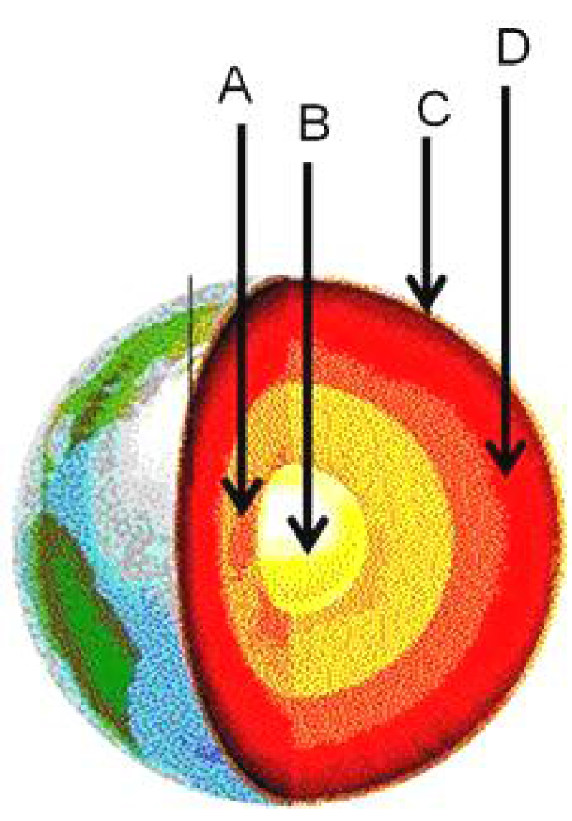
- What is the purpose of a control group?

The Lithosphere – Plate Tectonics, Volcanoes and Earthquakes
Match the layer of the Earth to the appropriate letter in the diagram.
- Inner Core __________
- Crust __________
- Outer Core __________
- Mantle __________

Match the boundary type to the appropriate diagram below.
- Transform Boundary __________
- Convergent Boundary __________
- Divergent Boundary __________
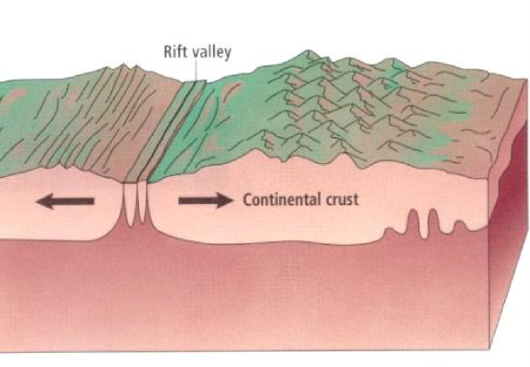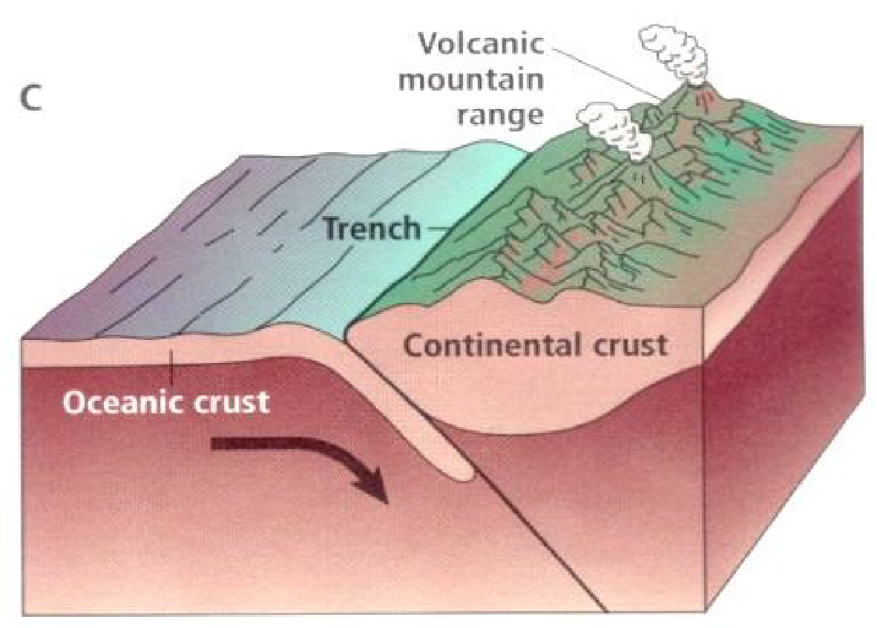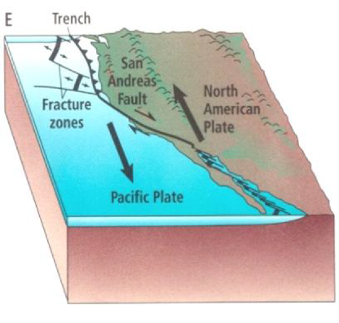
C
B
A
- Two plates collide and one goes other the other. The plate that subducts under the other is probably a ____________________ plate (oceanic or continental) and it gets pushed under because it is ____________________ (more or less) dense than the other.
- Explain what drives the movement of the tectonic plates. Draw a diagram.

- What is the process called when one plate is forced beneath another at a convergent plate boundary?

- The __________ states that Earth's crust and rigid upper mantle are broken into plates that move at different rates and in different directions.

  - Hypothesis of continental movement
  - Hypothesis of continental drift
  - Theory of plate tectonics
  - Theory of seafloor spreading

- A place where two tectonic plates slide laterally past each other is called a ____________________ boundary and is often associated with ____________________ faults.
- A place where two tectonic plates collide is called a ____________________ boundary and is often associated with ____________________ faults.
- A place where two tectonic plates separate is called a ____________________ boundary and is often associated with ____________________ faults.
- What were 3 pieces of Wegner’s evidence to support continental drift theory?

- Where do most volcanoes form?

- Draw a picture of each volcano in the boxes below. Be sure to show the shape of the volcano (steep sides, gentle slope, etc.)
Shield Volcano | Cinder Cone Volcano | Composite / Stratovolcano
Type of Lava: | Type of Lava: | Type of Lava:
Viscosity of Lava: | Viscosity of Lava: | Viscosity of Lava:
Type of Eruption: | Type of Eruption: | Type of Eruption:

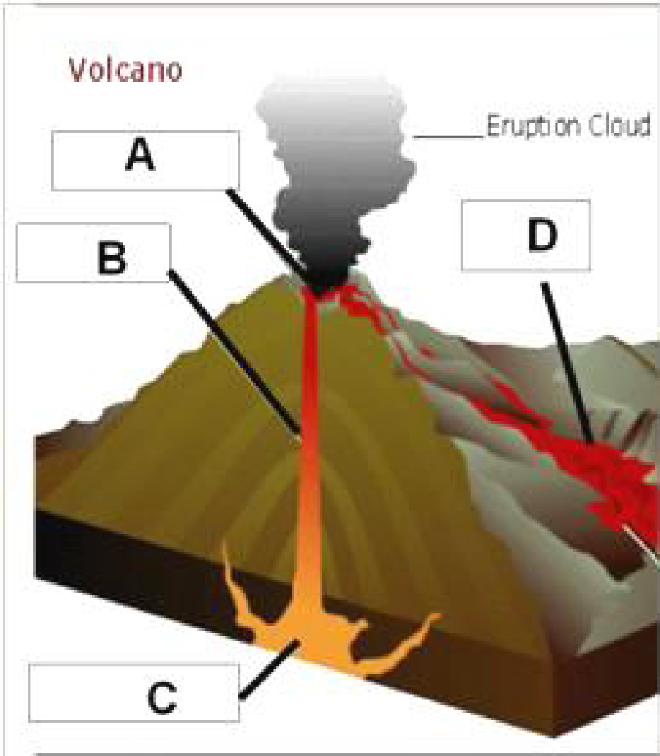
Match the volcano structure to the appropriate letter in the diagram.
- Magma Chamber __________
- Vent __________
- Lava Flow __________
- Crater __________

- What type of volcano is Mt. Saint Helens in Washington?
  - Composite/Stratovolcano
  - Cinder-cone
  - Shield
  - Super-volcano

- The Earth’s outer core is made of ____________________ (liquid, solid) and we know this because ____________________ (s, p) waves will not go through it.
- Describe the modified mercalli scale. (Include what it measures and the scale.)

- Fill in the following table below.
Type of Wave | Direction of Motion | # on Seismograph (1st, 2nd, 3rd)
Primary (P Wave)
Secondary (S Wave)
Surface Wave

- What is a large ocean wave that is generated by vertical motions of the seafloor during an earthquake called?

  - Tsunami
  - Earthquake
  - Volcano
  - Global Warming

- The Richter Scale is a logarithmic scale, meaning the numbers on it increase by a factor of ____________________.
- How many times larger is a magnitude 4 than a magnitude 1 earthquake on the Richter scale?

  - 10
  - 3
  - 100
  - 1000

- What type of instrument can measure the vibrations of an earthquake?

- Describe how tectonic plates can form mountains. Which types of plates collide to form mountains? Which two tectonic plates collided to form the Appalachian Mountains?

- What is a hotspot? Where do they form? Give an example of a hotspot.

- What is a rating from the Richter scale based on?

  - Size of the largest surface wave
  - Wavelength between the waves
  - Damage from the largest secondary wave
  - Frequency of the primary waves

True or False – If the statement is true, mark it with a T. If it is false, change the underlined word to make it true.
- __________ Secondary (S) waves are the type of seismic wave that are the last to be recorded on a seismograph and cause the most damage in an earthquake.
- __________ The crust is the thickest layer of the Earth.
- __________ Movement in the inner core moves the plates of the Earth.
- __________ When magma reaches Earth’s surface it is called lava.
- __________ Oceanic plates are made of more dense basalt rock.
- __________ The focus is where an earthquake originates, usually deep underground.
- Describe what of the following two pictures are showing. How do they relate to each other?
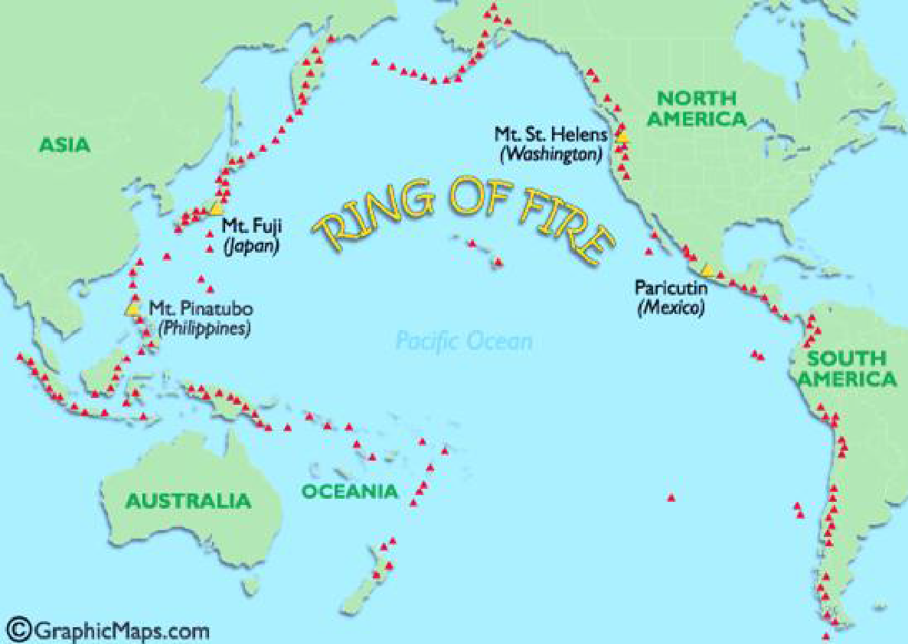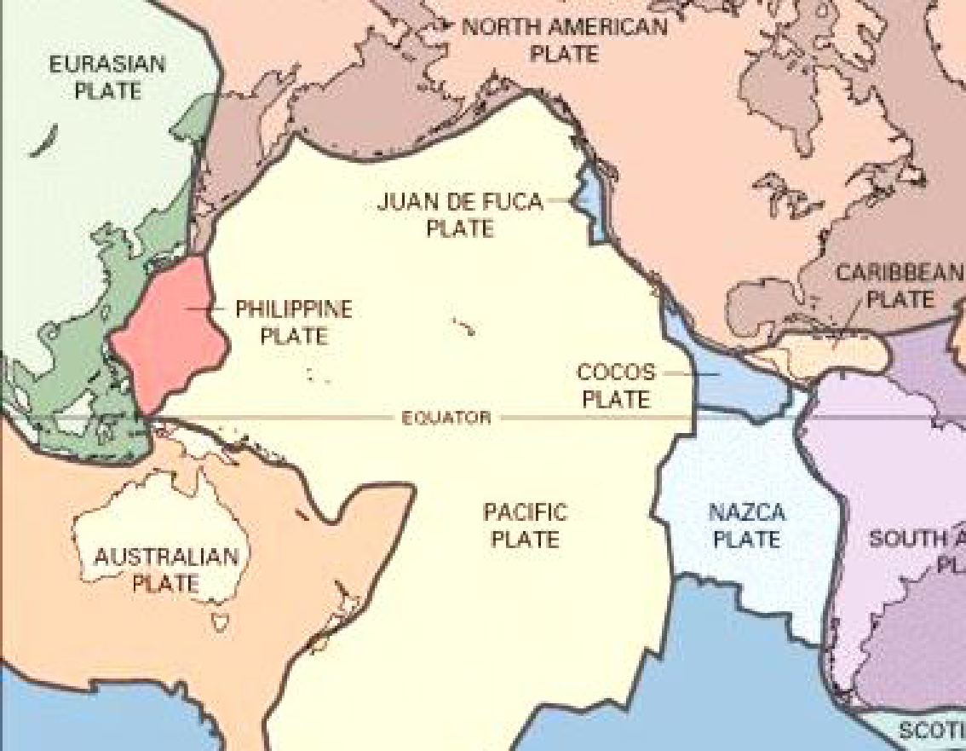

The Rock Cycle, Weathering, Erosion and Soil
- What is the process by which rocks at the Earth’s surface break down and change?

- Roots growing into a rock is an example of ____________________ weathering.
- Acid rain breaking down a rock is an example of ____________________ weathering.
- Which activity demonstrates chemical weathering?

  - Freezing of water in the cracks of a granite boulder.
  - Abrasion of a streambed by tumbling rocks.
  - Dissolving of limestone by carbonic acid.
  - Boulders falling from a cliff and shattering on the rocks below.

- What human activity causes acid rain to form?

  - Surface mining
  - Clear cutting

  - Fracking for natural gas
  - Burning fossil fuels, coal power plants and motor vehicle exhaust.

- How did weathering rates change on the statue of Cleopatra’s Needle when it moved from Egypt to New York? What caused that change?
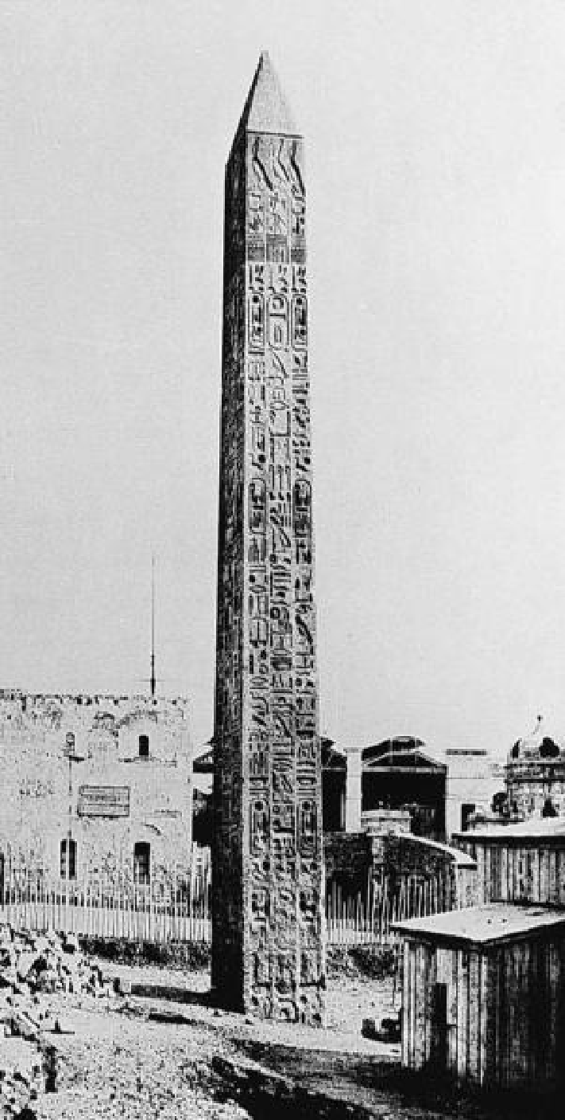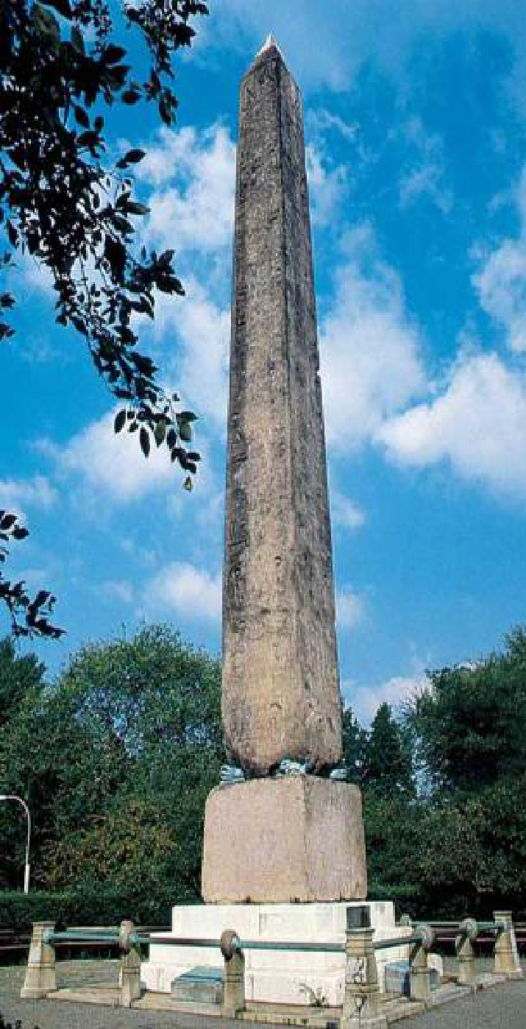
In Egypt for 3,500 years. | In New York for 100 years

- The movement of weathered material by wind or water is known as ____________________.
- How are deforestation and erosion rates linked? What about urbanization?

- Soil that has been moved to a location away from its parent material rock Is called _______________.

  - Transported soil
  - Organic-rich soil
  - Residual soil
  - Soil profile

- Eroded materials that are transported are finally dropped off in a process called ____________________.
- How is soil texture classified?

- Which of the following is responsible for giving surface soil a dark brown color?

  - Clay
  - Sand
  - Iron
  - Humus

- If you had a red or orange soil sample, there is likely a lot of which element in it?

- How is humus or organic matter formed in soil?

- Which of the following soil particles would likely cause the formation of micropores and have low permeability?

  - Clay particles
  - Sand particles
  - Silt particles
  - Sand and gravel

- A rock that forms from the lava flow of a volcanic eruption is best described as ____________________.
- Marble is formed when limestone changes under high heat and high pressure. What type of rock is marble?

True or False – If the statement is true, mark it with a T. If it is false, change the underlined word to make it true.
- __________ The smallest soil particles are clay particles.
- __________ The texture of a soil affects its ability to retain water and support plant life.
- __________ During the Great Depression, topsoil blew away in something called the Dust Bowl. This was an example of chemical weathering.
- __________ Oxidized iron turns soil red.
- __________ Dissolution is a form of mechanical weathering.
- __________ Sandy soils are the best soils for agricultural uses.

- There is much more chemical weathering of rocks in tropical climates and much more mechanical weathering of rocks in colder climates. Think of a few (2-3) reasons this happens.

- What are the five (5) characteristics of a mineral?

- What type of weathering is oxidation? What causes oxidation to occur?

- What are the two main types of mineral extraction (mining)? Which one causes the most environmental degradation?

Part II – Hydrosphere
- Compare and contrast adhesion and cohesion.

- What are hydrogen bonds? Draw a picture of how they form.

- Water has a ____________________ (high/low) specific heat. This causes it to heat up and cool down ____________________.
- Ice is ____________________ (more/less) dense than water so it ____________________ (sinks/floats).
- What is salinity?

- The greater the salinity, the ____________________ the density of water.
- What are two processes that add salt to seawater?

- What are two processes that remove salt from seawater?

- Which has a higher salinity, the Atlantic or the Pacific Ocean? Why?

- What causes surface ocean currents?

- What is the closest ocean current to us in North Carolina?

- What is a gyre?

- The ____________________ Effect causes gyres to rotate in the ____________________ direction in the Northern Hemisphere.

- Use the following terms listed below to complete the passage.
Cold Nutrients Offshore Trade-Wind Upwelling Vertically
In addition to moving horizontally, ocean water moves ____________________. The upward motion of ocean water is called ____________________. Upwelling waters originate from the bottom of the ocean and are ____________________. Areas of upwelling exist mainly off the western coasts of continents in the ____________________ belts. The trade winds blow surface water ____________________, and the surface water is replaced by upwelling deep water. Upwelling waters are rich in ____________________, which support abundant marine life population.

- Explain how sonar is used to determine the depth of an ocean.

- Describe the process of seafloor spreading. Draw a diagram.

- Explain how barrier islands like the Outer Banks form.

- Label the picture below with the following terms: infiltration, precipitation, evaporation, condensation, transpiration and runoff.
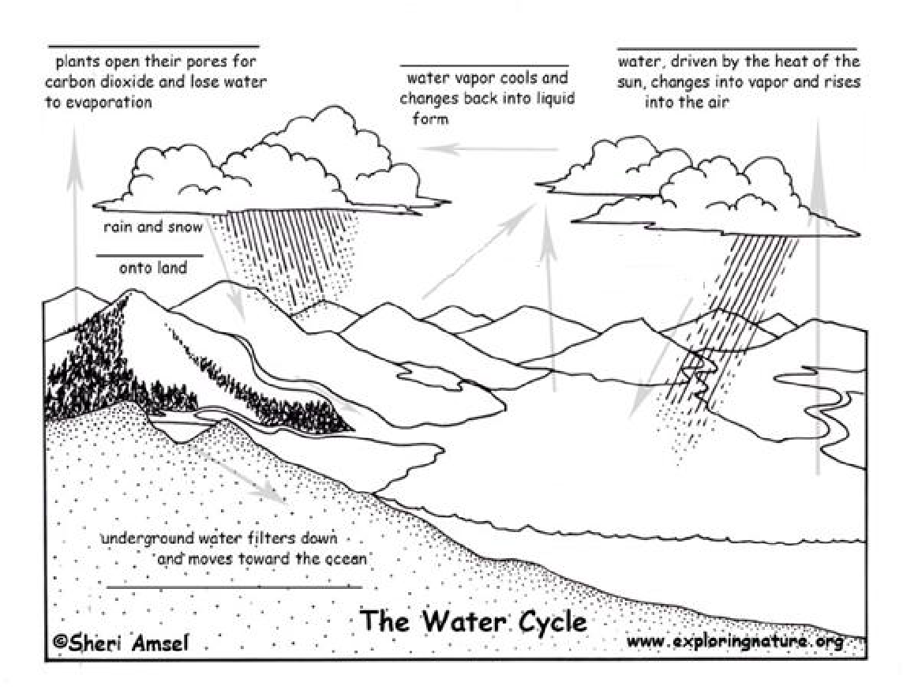
- What is an abiotic factor? Give two examples of abiotic factors of water quality.

- What is a biotic factor? Give two examples of biotic factors of water quality.

- What percentage of all the water on the globe is freshwater? Is it available for human use? If not, why not?

- Define turbidity. How is it tested?

- Why is high turbidity an indicator of poor water quality?

- Where does our drinking water come from?

- In countries without wastewater treatment facilities, are the lakes and river more or less polluted? Why?

- Define point source pollution. Give at least one example.

- Define non-point source pollution. Give at least one example.

- What happens to water in urban areas when it flows down storm drains? (Is it treated or not?)

- Describe two ways that water can gain higher levels of dissolved oxygen.

- Describe two ways that the amount of dissolved oxygen can decrease.

- How could a body of water get high levels of nitrates and phosphates?

- What are impervious surfaces? Give three examples of them. How do they impact the water cycle?

- What happens to most of the rain that falls in urban areas? Why?

- Does the total amount of water on Earth ever change? Why or why not?

- Explain how man-made eutrophication works, step by step. What causes it and how can it lead to “dead zone?”

- What is a watershed?

- What do we call the highest point or elevation in a watershed that separates one watershed from another?

- What are three different types of wetlands?

- What are three reasons wetlands are vitally important?

- What is alluvial fan? How do they form? Draw a diagram of an alluvial fan.

- What is a delta? How do they form? Draw a diagram of a delta.

- What is a meander? How do they form? Draw a diagram of a meander.

- Water is stored underground in ____________________ and can be tapped and brought to the surface using ____________________. Natural places where groundwater comes to the surface are called ____________________.
- What causes deep ocean currents?

- Describe the conveyor belt model of ocean water circulation.

- Where does most bottled water really come from?

- Why is it unsustainable to drink bottled water?

Part III – Atmosphere, Weather, Severe Weather and Climate
- Rank these gases in order from highest to lowest concentration of Earth’s atmosphere (highest concentration means that it makes up the biggest part of the atmosphere): carbon dioxide, water vapor, oxygen, nitrogen
Highest Lowest
- Molecules in a substance with a high temperature move ____________________ (fast/slowly), while molecules in a substance with a low temperature move ____________________ (fast/slowly).
- What are the three types of heat transfer? Give an example of each.

- What molecule is important because it blocks harmful ultraviolet rays from the Sun?

- Describe what happens to temperature as you travel higher into the troposphere.

- Describe what happens to air pressure as you travel higher into the troposphere.

- In which layer of the atmosphere is the ozone layer found?

- What would be the long-term effect if the ozone layer was destroyed? *Remember what ozone blocks!*

- Sketch a diagram of the water cycle. Be sure to label all the steps (evaporation, condensation, precipitation, transpiration, infiltration and surface runoff).

- What are condensation nuclei, and why are they important for cloud formation?
- Draw a picture of orographic lifting. Be sure to label the windward side of the mountains and the leeward side.

- Which is more dense, warm air or cold air?

- Why does warm air rise at a front and cold air stays close to the ground?

- Draw a convection cell. Label the high and low pressure arrows.

- What is wind? What causes it?

- Where on Earth are atmospheric low pressures found? Why?

- Describe cumulonimbus, stratus and cirrus clouds.

- Write the characteristics and full names of the air masses with the correct source region below.
 | mP | mT | cP | cT | cA
Full name:

Forms over:

Characteristics:

- The ____________________ Effect, where winds curve to their right in the Northern Hemisphere and left in the Southern Hemisphere, occurs due to the ____________________ of Earth.

- Which layer of the atmosphere is weather found in?

- Which type of severe weather is measured on the Fujita Intensity Scale?

- Fill in the following table on fronts below.
 | Warm Front | Cold Front | Stationary Front | Occluded Front
Forms When…

Associated Weather

Symbol on Weather Map

- Fill in the following table about the layers of the atmosphere.
Layer of Atmosphere | Characteristics or Function | Temperature Change (hot to cold or cold to hot?
Troposphere

Stratosphere

Mesosphere

Thermosphere

Exosphere

- Fill in the blanks using the following word bank:
Water Vapor Dew Point Temperature Convection Fahrenheit
Evaporation Latent Heat Condensation Coalesce
Heat and temperature are not the same. ____________________ is a measure of how rapidly or slowly molecules move. In contrast, ____________________ is the transfer of energy that takes place because of temperature differences. Temperature can be measured in degrees Fahrenheit, degrees Celsius, or Kelvins. The most commonly used temperature scale in the United States is ____________________. The atmosphere’s temperature plays a role in the formation of rain. The first step in cloud formation is when liquid water on the earth’s surface under goes ____________________ and turns into a gas. Now in the atmosphere, ____________________ turns from a gas back into liquid cloud droplets through ____________________. This process releases ____________________ heat. Those cloud droplets ____________________ together and eventually form drops big enough to fall from the sky as precipitation. The heat released goes on to fuel more ____________________ cells. ***Air must be saturated before condensation can occur. Saturation is the point at which the air holds as much water vapor as it possibly can. The ____________________ is the temperature to which air must be cooled at constant pressure to reach saturation. Until this temperature is reached, condensation cannot occur and rain cannot fall.

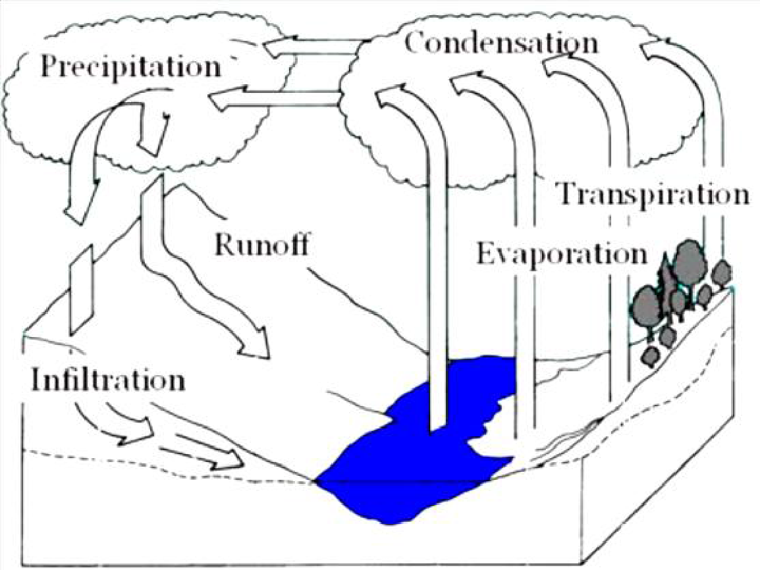
- Using the diagram to the right, which is the process of water vapor changing to a liquid?

- What is the main energy source behind the water cycle?

- What type of clouds produce thunderstorms?

- Describe the formation of a thunderstorm. Fill in the blanks with the appropriate vocabulary words. No word will be used twice:
Lift Coalesce Cool Moisture Precipitation Warmer
Updrafts Downdrafts Condenses Latent Convection Cell
In order for a thunderstorm to form, there must be abundant____________________ in the lower atmosphere, a mechanism to ____________________ the air, and the portion of the atmosphere through which the cloud grows must be ____________________. Air can only rise if it is ____________________ than the air around it. During the first stage of thunderstorm development, air rises vertically creating ____________________. Moisture ____________________ into cloud droplets, releasing ____________________ heat. Those cloud droplets ____________________ and eventually form precipitation. During the mature stage, ____________________ falls and cools the air around it. Cool air sinks creating ____________________. Updrafts and downdrafts form a ____________________. During the final stage, downdrafts eventually ____________________ the area where the warm air was fueling the storm. Updrafts stop, and the storm rains out the rest of its precipitation.

- Describe the formation of a tropical cyclone (hurricane). Fill in the blanks with the appropriate vocabulary words. No word will be used twice:
Coalesce Trade Wind Cells Dry Land Precipitation Low
Coriolis Effect Condenses Warm Convection Cell Latent Heat
Tropical cyclones form near the equator over ____________________ ocean water. Air is forced up due to disturbances that take place where the air from two ____________________ converges. Water vapor gas in the air ____________________ into liquid water releasing energy in the form of latent heat. Air that has been warmed by the release of latent heat rises creating ____________________ pressure at the ocean surface. More air moves in to fill its place. As the air rises it cools. Water droplets in the air ____________________ (come together). Bigger water drops fall from the sky as ____________________. Cool air falls back down to the warm ocean surface. This whole cycle of energy transfer through the heating and cooling of air is called a ____________________.
Because the Earth is spinning on its axis, the ____________________ causes the air of a tropical cyclone to rotate. Condensation releases more ____________________, fueling the rotation of the cyclone faster and faster. The storm loses energy when it moves over either ____________________ or cold water because it is cut off from its fuel source of warm water.

- The phenomena caused by the rotation of the Earth that causes winds to swirl in counter-clockwise in the Northern Hemisphere and clockwise in the Southern Hemisphere is called the ____________________ effect.

- Air always moves from ____________________ (low/high) pressure to ____________________ (low/high) pressure.

Rank | Category | Path of Destruction | Wind Speed (mph) | Duration (time)
F0 and F1 | Weak | Up to 3 miles | 60-115 | 1-10 minutes
F2 and F3 | Strong | 15+ miles | 110-205 | 20 minutes or longer
F4 and F5 | Violent | 50+ miles | More than 200 | 1 hour or longer
- The table above shows the Fujita Tornado Intensity Scale. Answer the following questions according to the table.
  - How fast are wind speeds during the most violent tornadoes?
  - How long can F0 tornadoes last?

- What is the calm center of a hurricane called?

- Where are the strongest winds in a hurricane located?

- What is the most dangerous part of a hurricane?

Climate and Climate Change
- Different paths of the Earth receive more or less solar radiation. Fill in the latitudes for each of the following climate zones on the Earth.
  - Tropics = latitudes ____________________ and ____________________ °N and °S
  - Temperate = latitudes ____________________ and ____________________ °N and °S
  - Polar = latitudes ____________________ and ____________________ °N and °S
- The area of the globe that receives the most solar radiation year round is called the ____________________.
- Climates are classified based on average monthly ____________________ and ____________________.
- What is the difference between weather and climate?

- How does Earth’s orbit affect our climate? Draw a diagram to represent this.

- Earth’s tropical regions receive more of the Sun’s energy than polar regions because they

  - Contain a greater percentage of dry land.
  - Have more vegetation to absorb the Sun’s energy.
  - Have a thinner atmosphere than the polar regions.
  - Receive a greater concentration of the Sun’s rays.

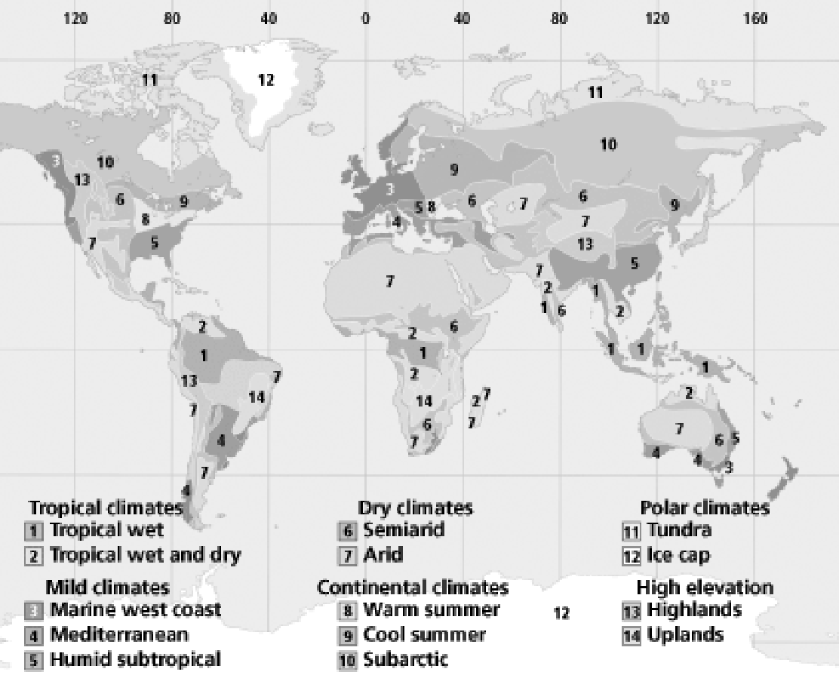
- According to the map, which two climates are found closest to the poles?

- According to the map, what type of climate do we have here in North Carolina?

- How do large bodies of water affect temperature?

- What minimum length of time is used to make climate normals (temperature and precipitation) for an area?

- Biomes are areas on Earth with similar ____________________, ____________________ and ____________________.
- Match the following biomes with the climate they are found in. Draw a line linking the matching terms:
Biome: | Climate:
Tundra | Continental
Desert | Tropical
Grassland | Polar
Tropical Rainforest | Mild
Deciduous Forest | Dry

- Throughout geologic time, the temperatures on Earth have been ______________.

  - Only warmer than it is today.
  - Always cooler than it is in the present.
  - A steady temperature.
  - Both warmer and cooler than the present.

- There have been more than ____________________ ice ages on planet Earth. The most recent ice age ended ____________________ years ago.
- What natural event can block solar radiation and have a short-term effect on climate?
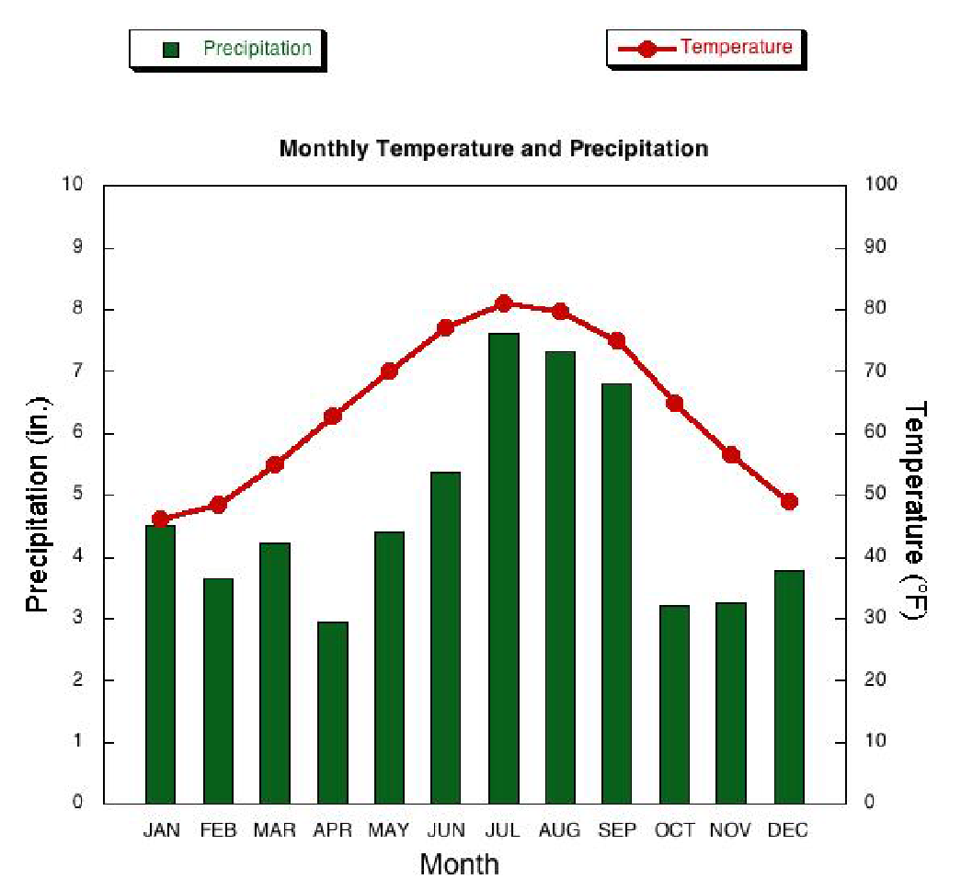
- Using the climagram on the right, which month has the lowest precipitation in Wilmington, NC?

- Approximately what temperature °F is the warmest average shown for this location?

- Which is the independent variable in this climagram?

- Explain the greenhouse effect. Draw a diagram to represent this.

- How could planting trees help reduce global warming?

- List three things that you can do to reduce your impact on global warming.

- List four common greenhouse gases.

- Which two greenhouse gases are most abundant in the atmosphere?

- Describe what has happened to levels of carbon dioxide in the atmosphere over the past 200 years.

- Describe what has happened to global average temperatures over the past 200 years.

- What are CFC’s? Where do they come from and how do they impact the Earth?

- What probably caused the major increase in CO₂ in the atmosphere?

  - Too much methane from cows
  - The Industrial Revolution
  - Sea-floor spreading
  - CFC’s in aerosols

- Describe at least three negative impacts of climate change.

- What country is most responsible for global climate change? Why?

- What is the thermal expansion of water? Why should you be concerned if the water in the ocean undergoes thermal expansion?

- As the ocean water gets warmer, what do you think will happen to the intensity and frequency of hurricanes? Why? (Think about the source of energy for hurricanes).

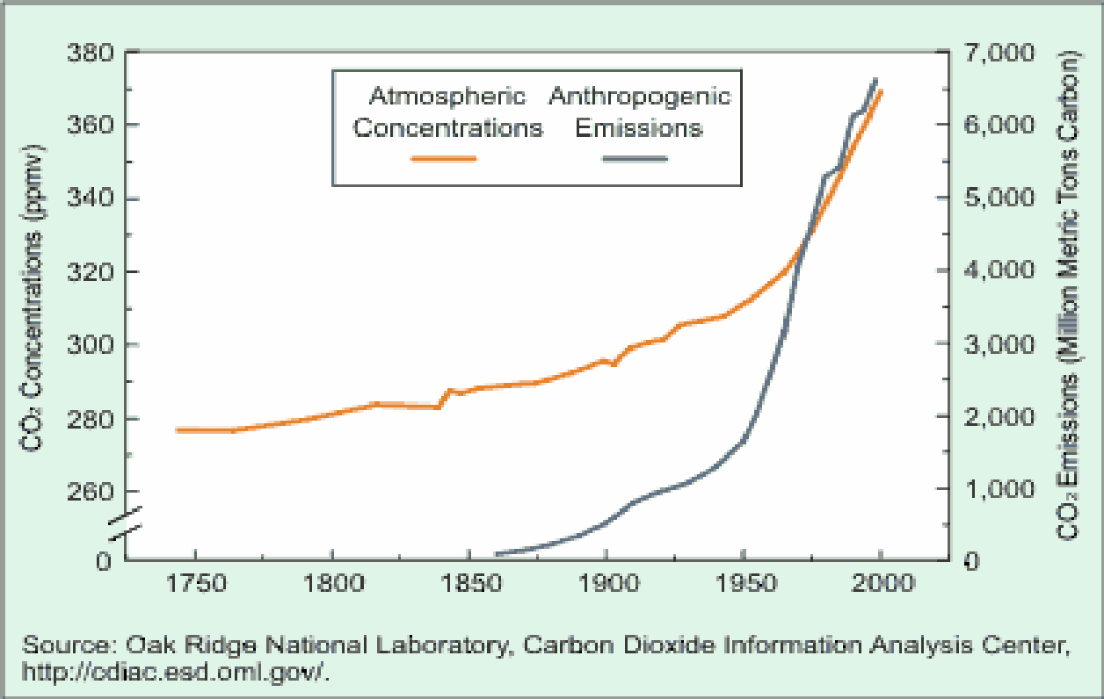
- Human-caused emissions of CO₂ are called anthropogenic emissions (anthro=man and pogenic=caused). Interpret the graph to the right to decide which statement is true about the relationship between human-caused emissions and atmospheric concentrations of CO₂
  - Atmospheric concentrations of CO₂ have steadily decreased as human-caused emissions have steadily increased.
  - Before 1850, humans were releasing so much CO₂ into Earth’s atmosphere that the values will not even fit on the scale of this graph.
  - There is absolutely no correlation between human-caused emissions and atmospheric concentrations of CO₂
  - Since the 1960’s, atmospheric concentrations of CO₂ have risen at a rate approximately equal to that of anthropogenic emissions.

True or False – If the statement is true, mark it with a T. If it is false, change the underlined word to make it true.
- _______________ Large bodies of water heat up and cool down more slowly than land.
- _______________ When the Earth’s orbit around the Sun is more of an elliptical shape, the Earth is farther from the Sun and colder.
- _______________ There have been at least 5 major ice ages in Earth’s past.
- _______________ The Earth is currently in an interglacial interval.
- _______________ Greenhouse gases make up 10% of the Earth’s atmosphere.
- _______________ Scientists agree that global warming is happening but disagree about the causes or future implications.

Part IV – Astronomy Review
- What is a geocentric model of the solar system?

- What is a heliocentric model of the solar system?

- What is retrograde motion, and what did it tell astronomers? Draw a diagram.

- Explain why there are different seasons on Earth. What does it have to do with the tilt of the Earth? Draw a diagram.

- List the planets in order from the closest to the Sun to furthest from the Sun.

- Which planets are terrestrial?
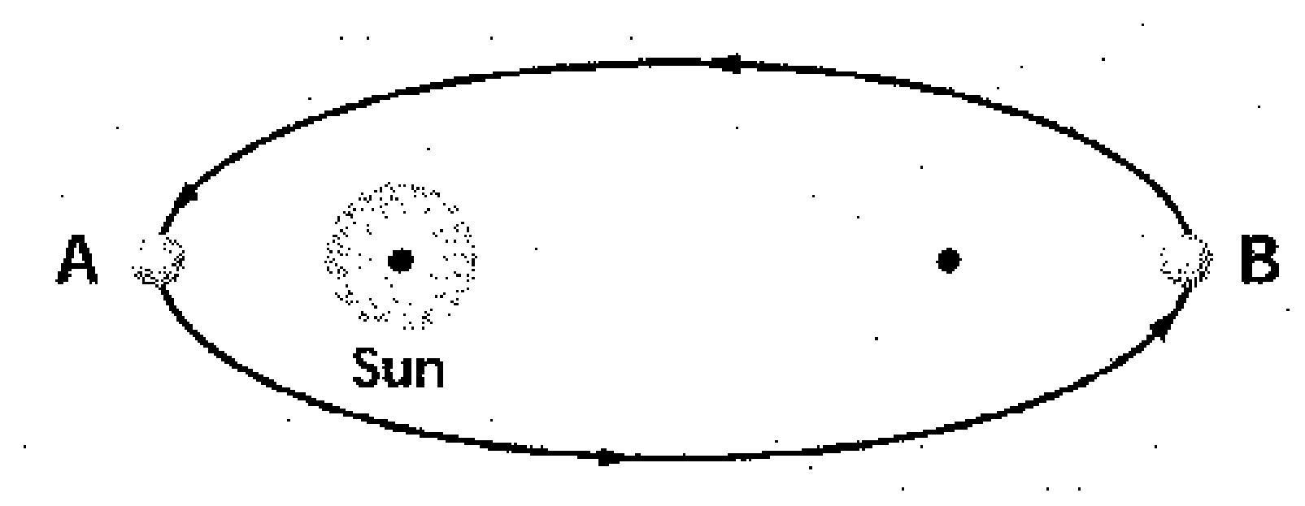
- Which planets are gas giants?

- In the diagram to the rigth, what point is the perihelion? Which point is the aphelion?

- Kepler’s First Law says that all planets orbits are ____________________ shaped.

- What does Kepler’s Second Law state?

- What does Kepler’s Third Law state?

- What is fusion? How does it work in stars?

- What is the difference between fission and fusion?

- Define the terms rotation and revolution. Draw a diagram for each term to demonstrate your understanding.

- What is precession? What effect does it have on Earth?

- What is nutation? What effect does it have on Earth?
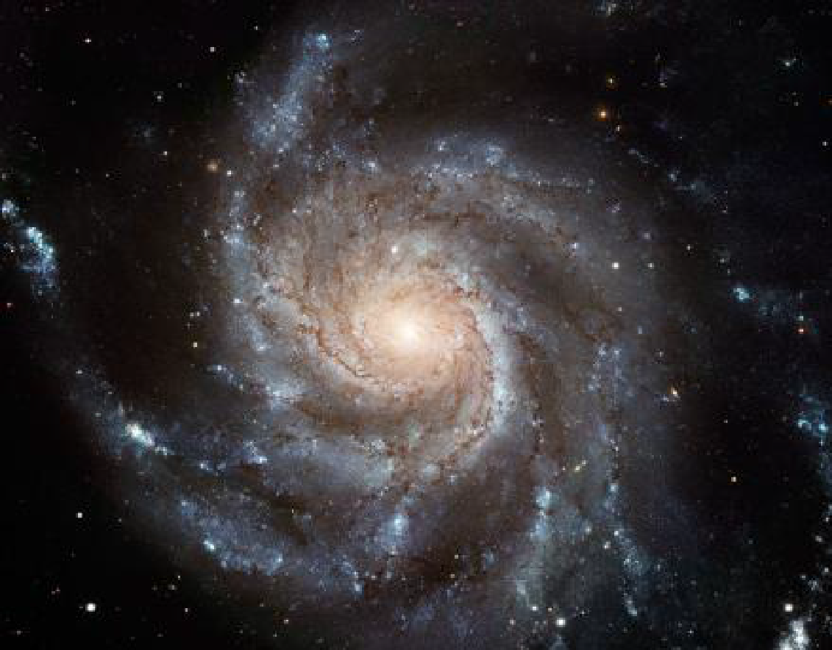

- Identify the type of galaxy in the picture to the right and give an example of the galaxy type.

- Using the image to the right, draw an arrow to indicate where our solar system would be located within this galaxy if it were our galaxy.

- What are the three types of galaxies? Rank them in order of abundance from greatest to least.

- What do scientists think are at the center of most, if not all galaxies?

- Earth’s tilt in combination with its orbit around the Sun causes the ____________________.

- The phases of the Moon cause gravitational pull on the water in the oceans and cause ____________________.

- What is a neap tide? Diagram the two phases of the Moon that correspond with a neap tide (show the location of the Sun, Moon and Earth).

- What is a spring tide? Diagram the two phases of the Moon that correspond with a spring tide (show the location of the Sun, Moon and Earth).

- Recent observations show that the rate of expansion of the universe is ____________________ (speeding up/slowing down).
- What contains 99% of the mass in the solar system and controls the motions of the planets?

- Describe how the Doppler Effect allows us to “see” the movement of distant stars.

- What does barycenter mean? Draw a diagram to demonstrate the barycenter point between Earth and the Sun.

- Describe the likely lifecycle of our Sun (a main sequence star) from before it was “born” until it “dies.”

- Describe the lifecycle of a more massive star like a blue supergiant star from before it was “born” until it “dies.”

- What is the combination of lightweight nuclei into heavier nuclei, such as four hydrogen nuclei combining to form a helium nucleus?

- What is the section of the H-R diagram into which about 90% of stars fall?

- What states that the universe began as a point and has been expanding ever since?

- What is a small, massive, dense object that has a gravity so immense that nothing – not even light – can escape it?

Matching – Match each item with the correct phase below.

- __________ Spectrum of light seen as stars are moving farther away from the observer.
- __________ Occurs when the Moon passes through Earth’s shadow.
- __________ Spring day characterized by day and night of equal lengths.
- __________ Occurs when the Moon passes directly between the Sun and Earth.
- __________ Spectrum of light seen as stars are moving closer to the observer.

  - Blue shift
  - Vernal equinox
  - Lunar eclipse
  - Solar eclipse
  - Red shift

- __________ Statement that planetary orbits are elliptical, not circular.
- __________ Statement that planetary orbits speed up when closer to the gravitational pull of the Sun.
- __________ Cloud of dust and gas that formed the Sun and planets.
- __________ A natural phenomenon by which physical bodies attract with a force proportional to their mass.
- __________ Statement that planetary orbits closer to the Sun move faster than those farther away from the Sun.

  - Kepler’s First Law
  - Gravity
  - Kepler’s Second Law
  - Nebula
  - Kepler’s Third Law

- Use the terms below to label the following diagrams:
Foci Major Axis Perihelion Aphelion Sun

